Web Scraping Sample projects

Aim:Using Python to scrap the data

Store data in a csv file

Tools:Jupter notebook, python, Beautifulsoup, Requests & Pandas

1️⃣ A Web scrap script for Rental Accommodation in Los Angeles from [Los Angeles Homes For Rent - Los Angeles, CA Homes For Lease | Residential.com™](https://www.residential.com/homesearch/for_rent/CA/Los_Angeles)

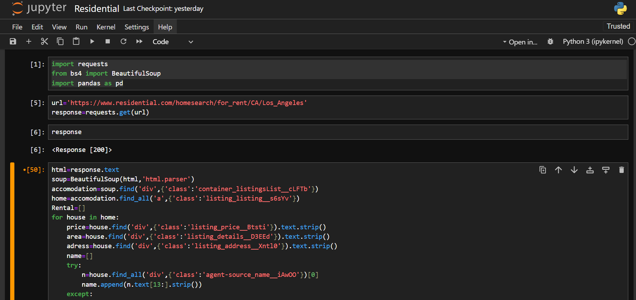

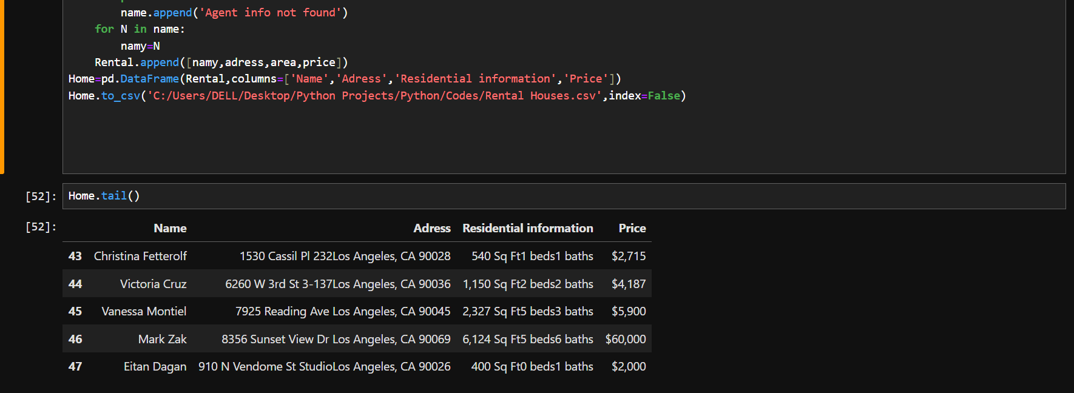

Scraped Data in CSV fomat

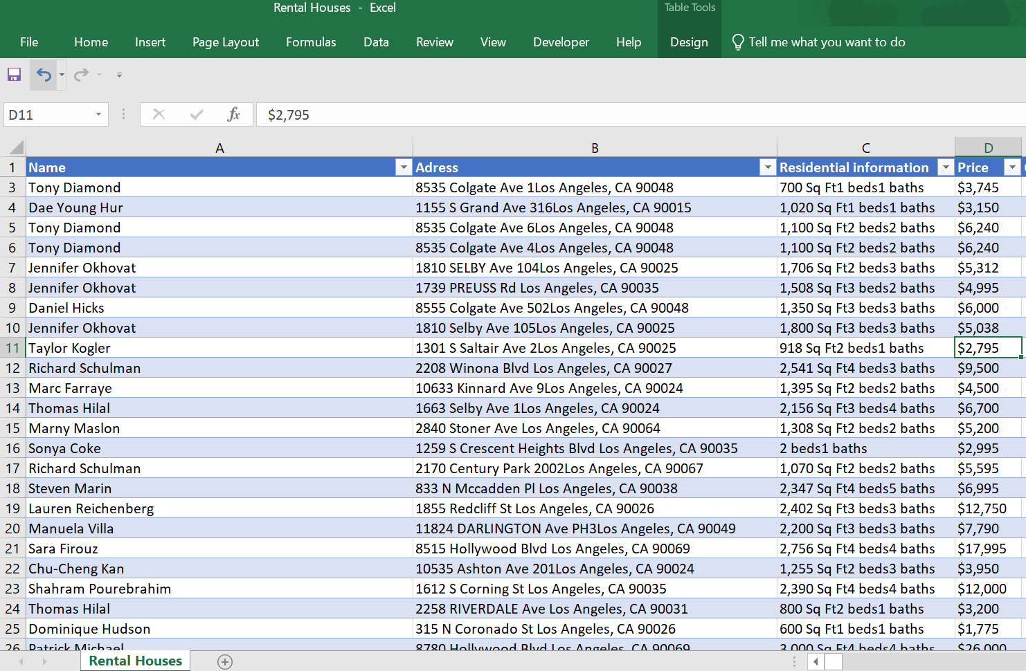

2️⃣ Scraped Data from [Effie Cases - GWA - Germany's Leading Agencies](https://www.gwa.de/effie-cases/) script

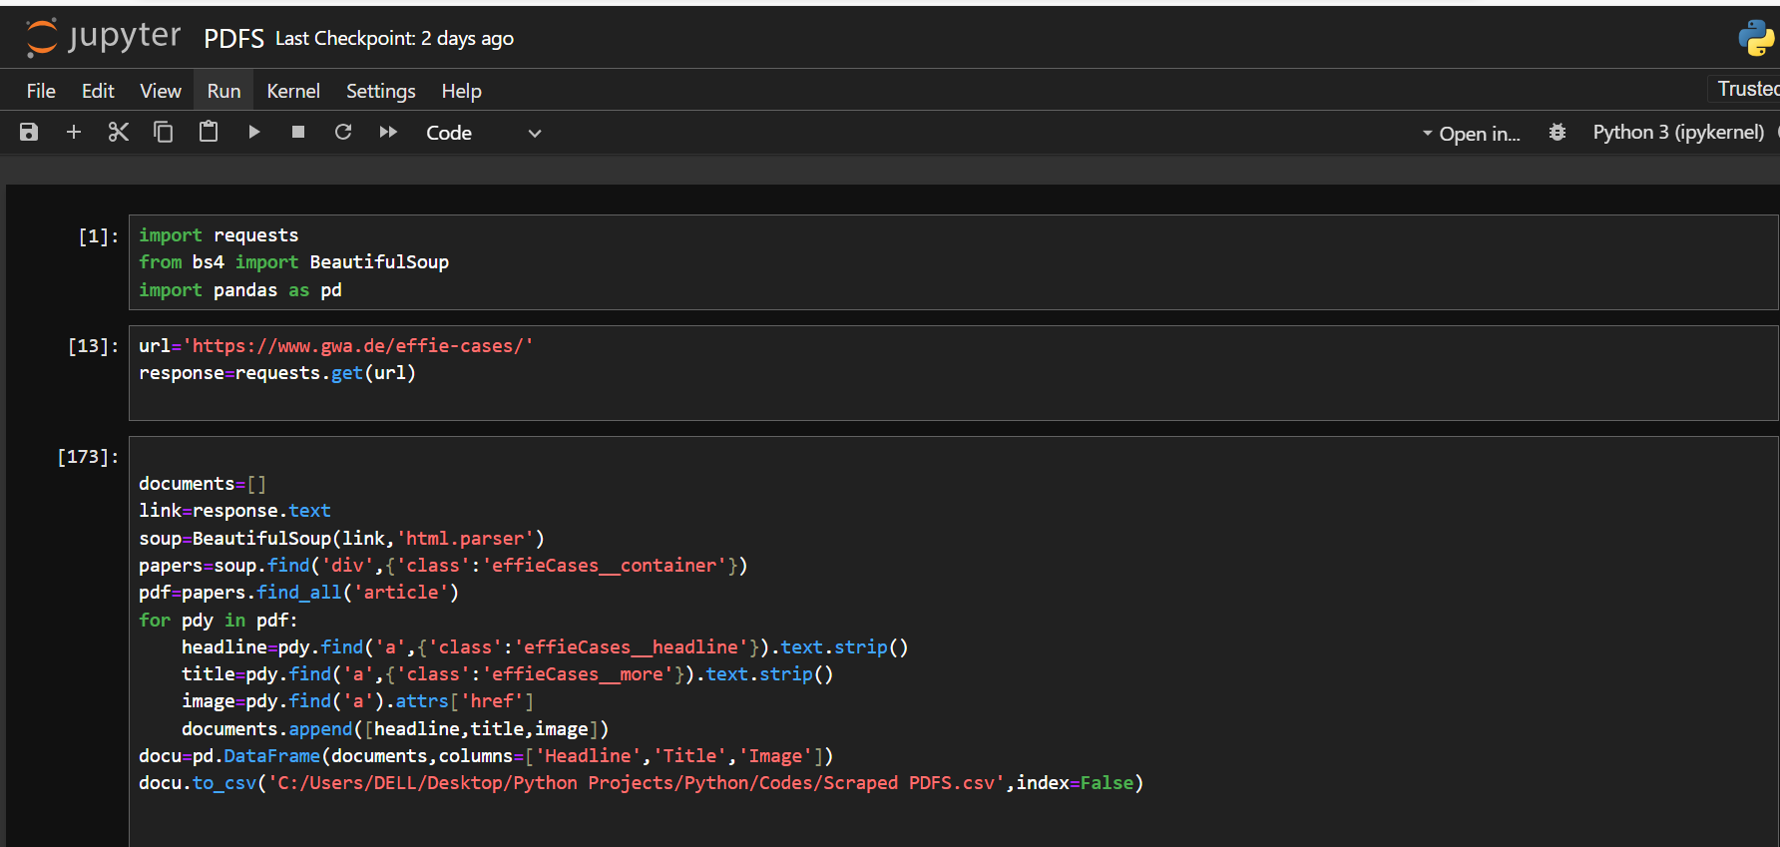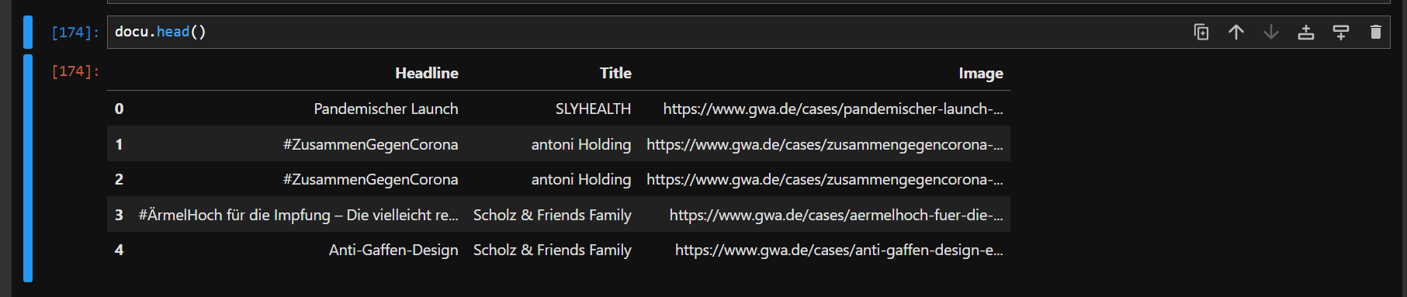Scraped into a CSV File

